Creating Crazy8s with SignalR & Blazor: Day 4 Part 1 –

time index 25:00 - Starts talking about SignalR design and has good concepts.

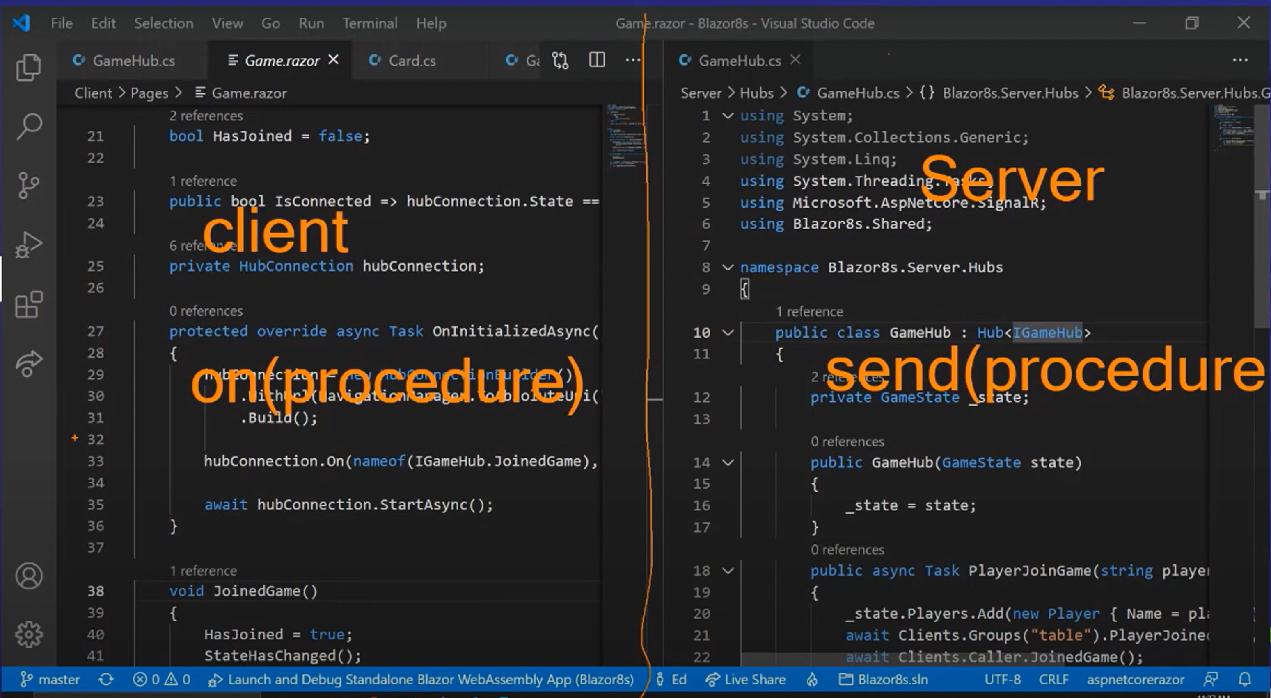

Client sends command

Server sends a command to the client

Time index 35:13 – some good Slide show content